Ideation Phase
Define the Problem Statements

Date | 15-7-2026
Team ID
Project Name | Book Store
Maximum Marks

Customer Problem Statement – Theory (BOOKSTORE Project): A Customer Problem Statement is a clear description of the challenges faced by customers while using existing products or services. It helps developers understand the customer's perspective and identify the real problems that need to be solved. By focusing on customer needs, the development team can create a solution that is useful, user-friendly, and efficient.
In the BOOKSTORE project, customers such as students, teachers, professionals, and book readers often face difficulties in finding the books they need. Traditional bookstores may have limited stock, require customers to visit multiple stores, and consume a significant amount of time. Existing online platforms may also have complex navigation, limited search features, or an inconvenient purchasing process. These issues reduce customer satisfaction and make buying books more difficult.
Book sellers also experience problems in managing their inventory, updating book details, processing orders, and maintaining customer records. Manual management increases the chances of errors and requires additional time and effort. Administrators need an efficient system to manage users, sellers, books, and orders while ensuring security and smooth platform operation.
The proposed BOOKSTORE application addresses these challenges by providing a web-based platform developed using the MERN Stack (MongoDB, Express.js, React.js, and Node.js). The system allows customers to search books, view book details, add books to a cart, place secure orders, and track purchases. Sellers can efficiently manage inventory and orders, while administrators can monitor the entire platform through a dedicated dashboard.
By understanding the customer's problems and designing features that directly address them, the BOOKSTORE project aims to provide a convenient, secure, and reliable online bookstore experience. This improves customer satisfaction, reduces manual effort, increases operational efficiency, and creates a better experience for buyers, sellers, and administrators.
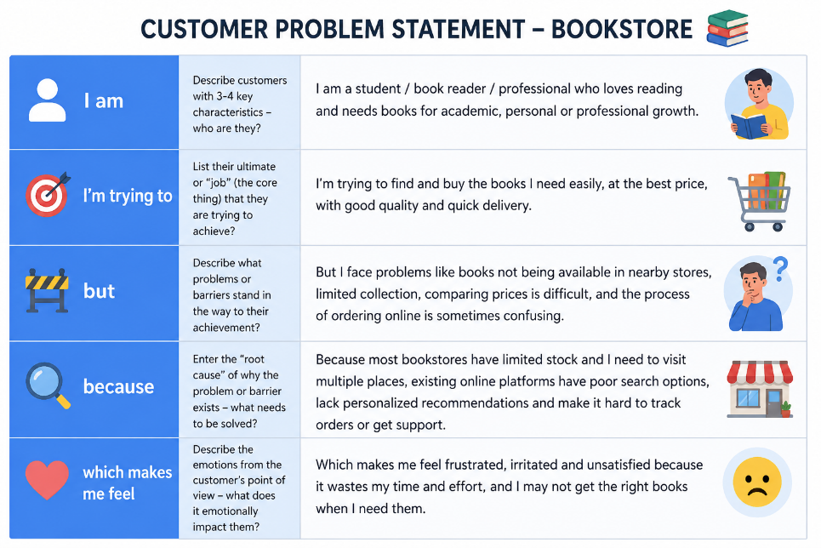
Example:
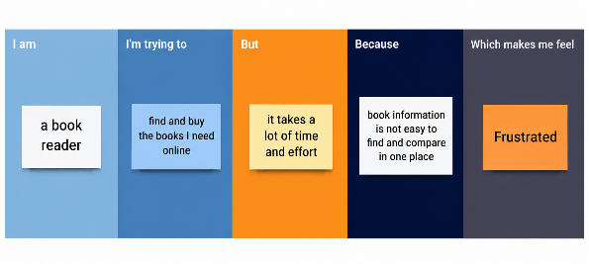
Problem Statement (PS) | I am (Customer) | I’m trying to | But | Because | Which makes me feel
PS-1 | A student/book reader. | Buy the books I need online quickly and easily. | I cannot always find the required books in nearby stores or compare prices easily. | Physical bookstores have limited stock and searching takes a lot of time. | Frustrated, disappointed, and inconvenienced.
PS-2 | A book seller | Sell and manage my books efficiently through an online platform. | Managing inventory, updating book details, and handling customer orders manually is difficult. | There is no simple and centralized system to manage my bookstore operations. | Stressed, inefficient, and likely to lose customers.

